# Unsuccessful login attempt, with no username or password

1. Open the **CulturedRestaurant** application
2. Select **Login**

Notice that the user is not redirected to another page, and a message saying that the login in attempt was unsuccessful.

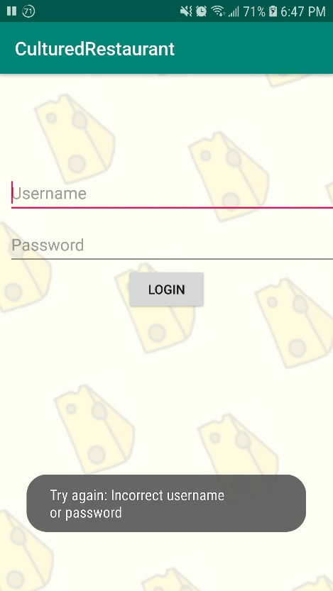

# Unsuccessful login attempt, with a username but no password

1. Open the **CulturedRestaurant** application
2. In the **Username** field, enter: **Customer01**
3. Leave the **Password** field blank
4. Select **Login**

Notice that the user is not redirected to another page, and a message saying that the login in attempt was unsuccessful.

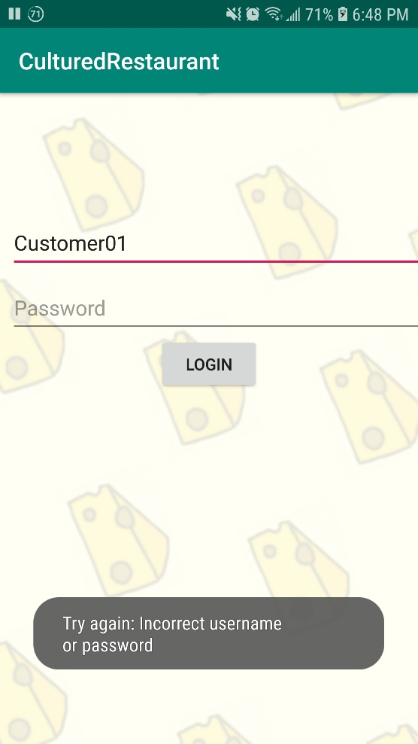

# Unsuccessful login attempt, with no username but a password

1. Open the **CulturedRestaurant** application
2. Leave the **Username** field blank
3. In the **Password** field, enter: **Gift**
4. Select **Login**

Notice that the user is not redirected to another page, and a message saying that the login in attempt was unsuccessful.

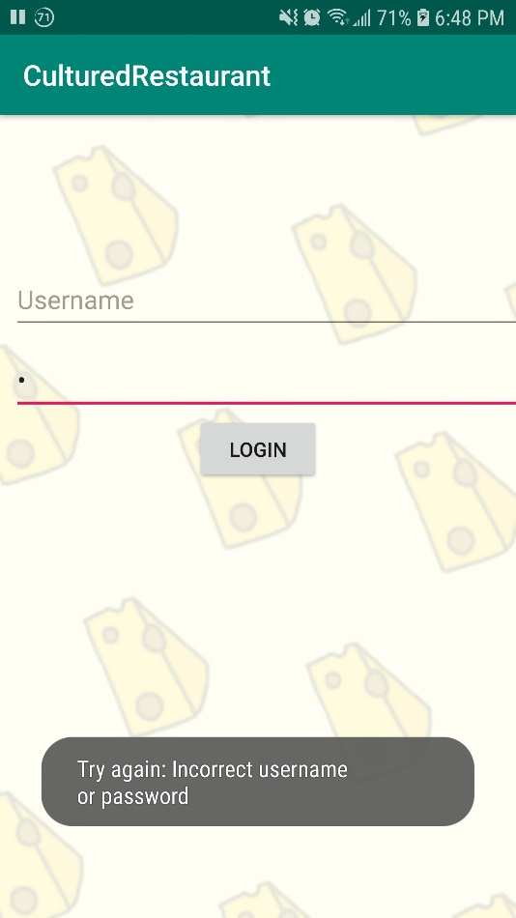

# Unsuccessful login attempt, with incorrect username and password

1. Open the **CulturedRestaurant** application
2. In the **Username** field, enter: **Customer01**
3. In the **Password** field, enter: **Gift**
4. Select **Login**

Notice that the user is not redirected to another page, and a message saying that the login in attempt was unsuccessful.

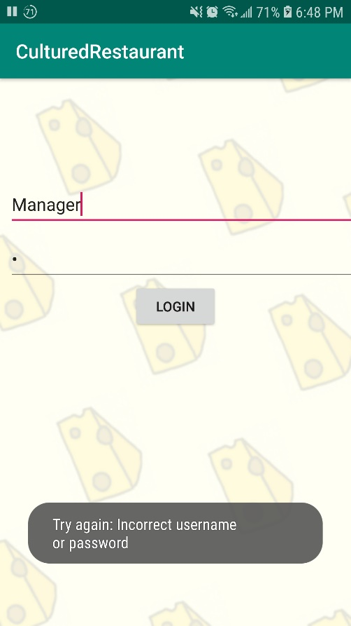

# Successful Customer login

1. Open the **CulturedRestaurant** application
2. In the **Username** field, enter: **Customer01**
3. In the **Password** field, enter: **“ “** (A single space character)
4. Select **Login**

Notice that the user is redirected to the first customer page, where they choose if the order is to-go or dine-in, and a message saying that the login in attempt was successful.

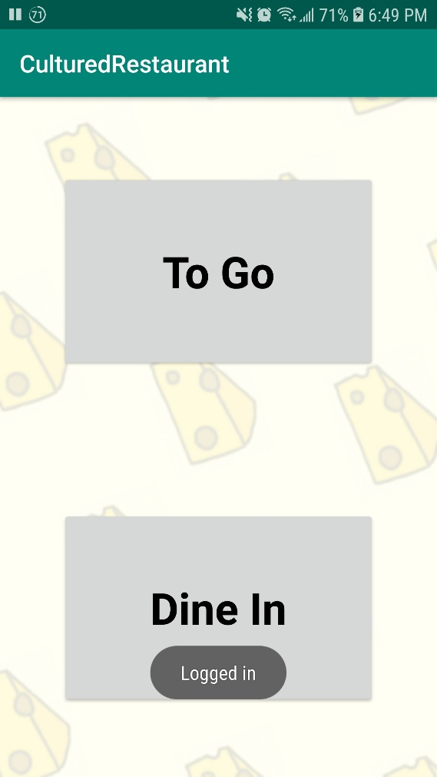

# Successful Manager login

1. Open the **CulturedRestaurant** application
2. In the **Username** field, enter: **Manager**
3. In the **Password** field, enter: **Gift**
4. Select **Login**

Notice that the user is redirected to the first manager page, and a message saying that the login in attempt was unsuccessful.

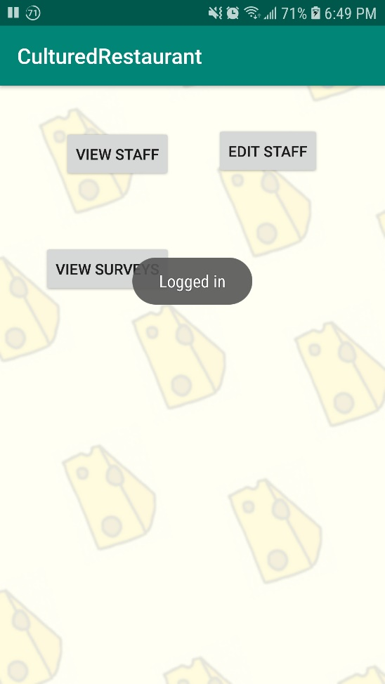

# Successful Wait staff login

1. Open the **CulturedRestaurant** application
2. In the **Username** field, enter: **waitStaff01**
3. In the **Password** field, enter: **Ruler**
4. Select **Login**

Notice that the user is redirected to the first wait staff page, and a message saying that the login in attempt was unsuccessful.

